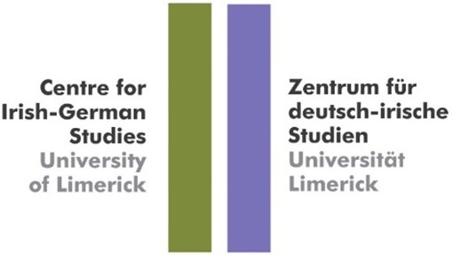

Irish-German diplomatic relations – towards the 100th anniversary
Marking the publication of Irish-German Diplomatic Relations (1929-2019) (Irish-German Studies 13, Wissenschaftlicher Verlag Trier 2020)

18 February, 11am – 1pm Online

Welcome – Prof Gisela Holfter, Director Centre for Irish-German Studies

Opening - Prof Kerstin Mey, President University of Limerick

I. Irish-German relations from a political and diplomatic angle - Strengths/weaknesses/threats and opportunities
Speakers: Niall Burgess, Secretary General Dept of Foreign Affairs; Miguel Berger, State Secretary of the German Federal Foreign Office; H.E. Deike Potzel, German Ambassador to Ireland and Dr Nicholas O’Brien, Irish Ambassador to Germany

II. “My vision for 100 years of Irish-German diplomatic relations – in 100 seconds”
Video collage, contributors include experts in Irish-German relations and key stakeholders

III. Irish-German relations and important highlights – Competition of student videos for the prize jointly sponsored by the German and Irish embassies (online voting of audience)

IV. Open audience discussion on Irish-German (diplomatic) relations and their future with H.E. Deike Potzel and H.E. Dr Nicholas O’Brien

V. Announcement of the winner of the video competition and the GILBA (German Irish Lawyers and Business Association) award

Please register here: https://us02web.zoom.us/webinar/register/WN_vlouDcqzQOGqoVirIcroEg

