City, Space, and Spectacle in
Nineteenth-Century Performance

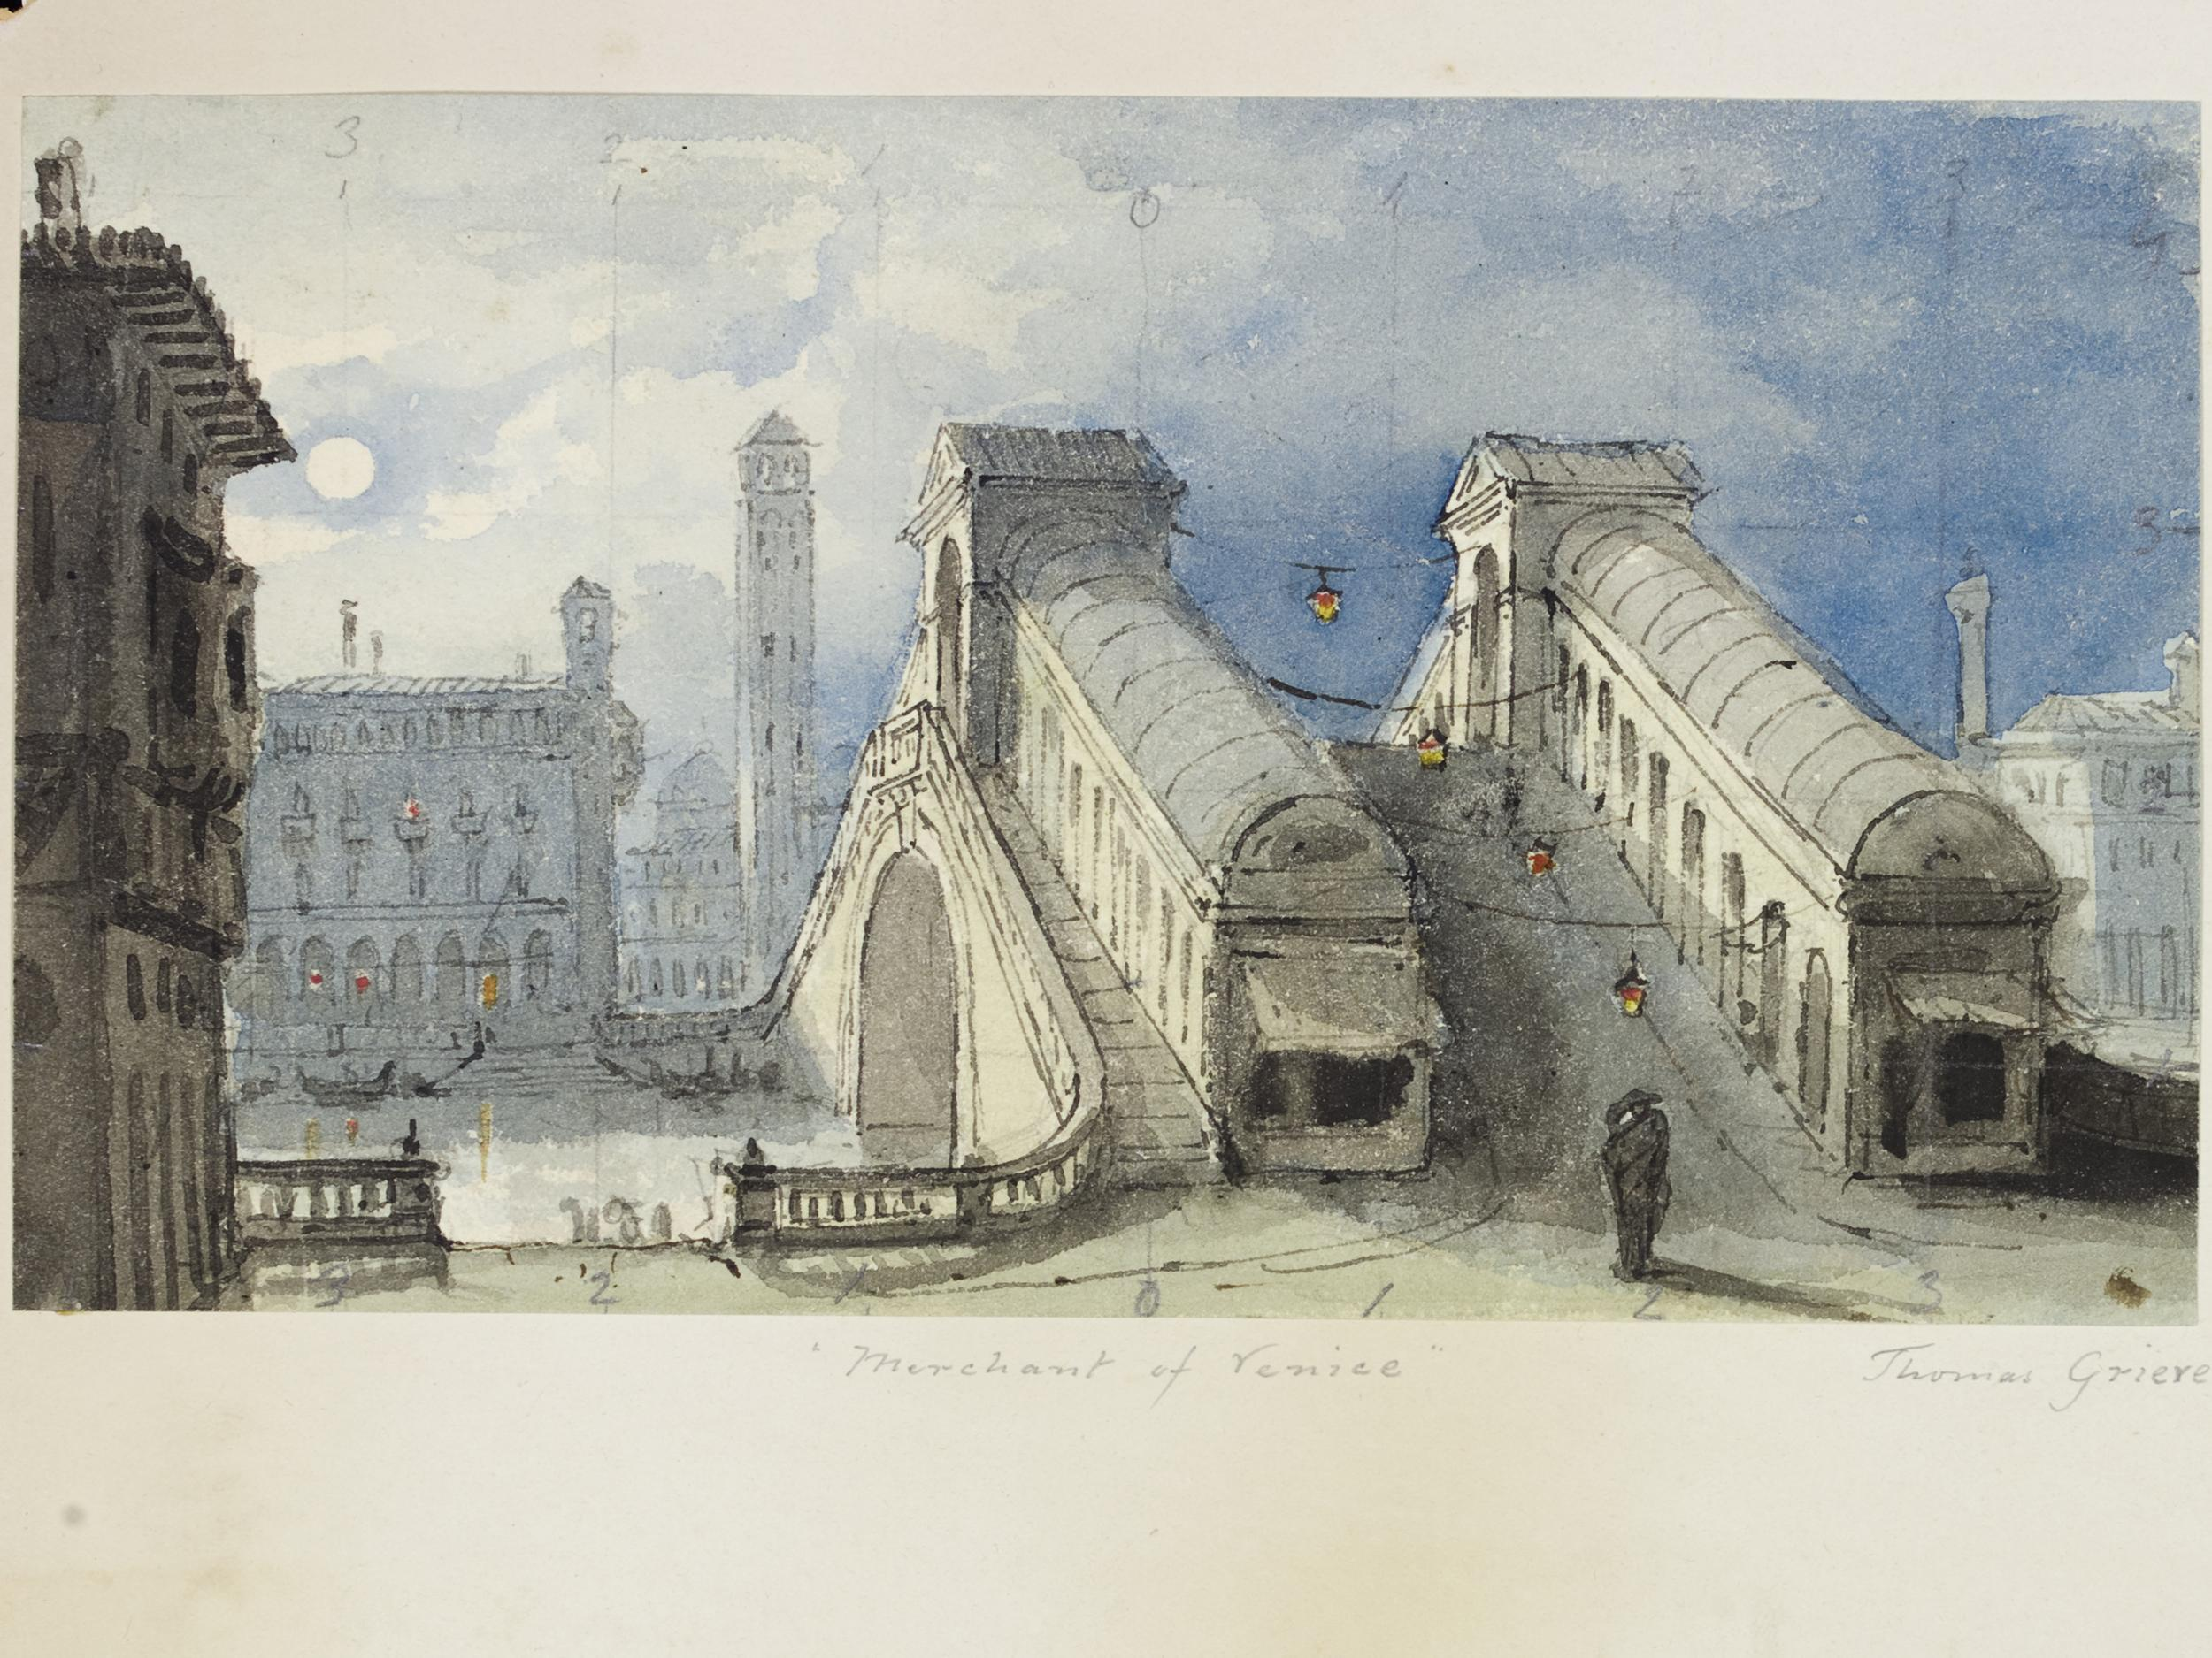

© Victoria and Albert Museum

Palazzo Pesaro-Papafava, Venice
University of Warwick
8 – 10 June 2018

Conference Dedicated to the Memory of Michael Booth, 1931 – 2017

Convened by the editors of Nineteenth Century Theatre and Film, Sharon Aronofsky Weltman, Jim Davis, Janice Norwood, & Patricia Smyth

Contents

Tributes to Michael Booth 4
Tributes to Victor Emeljanow 9

Conference Timetable 10

Palazzo Pesaro-Papafava, Local Information and Map 19

In Memoriam:

Michael R. Booth (1931-2017)

Emeritus Professor of Theatre, University of Victoria

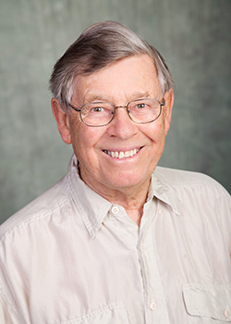

A Tribute

Tracy C. Davis, Barber Professor of Performing Arts, Northwestern University

In 1996, ASTR honored Michael R. Booth as its Distinguished Scholar, recognizing a lifetime of work on nineteenth-century British theatre. He was born in Shanghai, where his father was manager of the P&O Bank, and fled with his parents from the chaos of the Sino-Japanese War to Victoria, British Columbia where his precocity flourished. He began his undergraduate studies at Victoria College, aged 16, and matriculated from the University of British Columbia, BA Hon (English) in 1951. He was a great raconteur, and told many stories at his own expense, for example that he gone away to university to study English with the conviction that Gone with the Wind was the ultimate in literary achievement. No wonder, we might conclude, that he would later champion things so outré as melodrama, burlesque, pantomime, and extravaganza.

Michael took his MA at the University of London, then returned briefly to UBC to teach English. In this period, he discovered that a succession of gold rushes resulted in theatres being built throughout the interior of British Columbia, many of which remained amid the abandoned flumes and bars of ghost towns. Leading stars of the British theatre had ventured to these theatres, and Michael wanted to know what this was all about. When he returned to London to take his PhD, the very idea that one could make a scholarly career out of Victorian drama was so counter-intuitive that he was obliged to write his dissertation on the eighteenth century; still, he pushed the topic as close to the nineteenth century and as relevant to performance criticism as he could get away with.

During this period he met his first wife, Jenifer, a librarian at the British Library. They resettled in Canada. While on faculty of the English Department at Royal Military College (1960-66), he found Kingston, Ontario to be a nice town but lacking in extramural activity. Opportunity came knocking. At this time, an enormous corpus of nineteenth-century plays was being brought out by Readex: printed plays, manuscript plays, and prompt books were comprehensively photographed and the texts miniaturized on card paper that required a special machine for enlargement. RMC bought a subscription and Michael systematically read each instalment as it was issued.

As baby boomers matured, Canadian universities expanded and in this process qualified Canadians who could fill new posts were cherished. The University of Guelph headhunted Michael to become its founding chair of theatre (1967-75). When the University of Warwick, just twelve years old, created its Department of Theatre Studies in 1975, Michael moved to England to become its first head and professor. The designation Theatre Studies recognized a less literary, more comprehensive approach to the discipline and this was reflected in the curriculum that Michael and his earliest colleagues, including Clive Barker, championed. Despite his scholarly specialty, Michael relished theatre of all kinds, particularly the avant-garde, and so built an undergraduate curriculum that emphasized political theatre and social engagement as well as theatre history. During this period, he served the Society for Theatre Research in various ways, including as editor of Theatre Notebook. In 1984, Michael responded to two more calls: the Thatcher government’s incentives to trim the payroll by giving professors early retirement packages and the invitation to return to British Columbia to chair the theatre department at the University of Victoria. This was a happy homecoming, and he remained in the department until 1996.

Michael never learned to type, let alone use a computer. His prodigious output was accomplished the old fashioned way, in an era when academics and typists had symbiotic occupations. He became my doctoral supervisor just after he finished his groundbreaking book Victorian Spectacular Theatre. Since, in those days, dissertators drowned in index cards and other scraps of paper, I asked him how he went about his work. “The first day of my sabbatical I sat down without a thought in my head. My desk had nothing on it but a pad of paper and a pen. Then I just started writing.” This only slightly disingenuous marvel was accomplished by dint of a prodigious memory and capacity to organize masses of detail. Indeed, he knew his argument and put his hand on each corroborating snippet as the need arose, drawing upon his personal library and collections of Victorian paintings, especially watercolors, and promotional materials that he had painstakingly amassed. But, to round out this reminiscence, I will add that he also halted work punctually for morning coffee (never tea) and afternoon tea (never coffee) even if this meant stopping mid-sentence, heedless of remoteness from the desired provisions. For him, academic work was a matter of routine, and long before slogans about work/life balance came to the fore it was clear to everyone that he would get on with the job, but only after a morning swim, and carry on with the job as long as necessary, but that these breaks were sacrosanct.

Though a dedicated undergraduate teacher, Michael had a laissez-faire approach to postgraduate supervision. He told me that he had seen his doctoral advisor precisely four times: first at the mixer welcoming new students, once when sent on an errand to purchase pipe tobacco, another time through the glass panel of his advisor’s door, and finally at his viva voce when he defended his dissertation. He was determined to be approachable, and we talked far more often during intervals at the theatre than in his office. He was much in demand and invitations took him to Australia and to a visiting professorship at Columbia University, where he stepped in for Martin Meisel in 1984, offering a course on farce. Those who knew him chiefly through conferences might describe him as avuncular, and decidedly idiosyncratic. The finer points of political correctness eluded him, but so too did sartorial vanity. What mattered was advocacy for his field, and he carried this out by directing as well as editing and writing about nineteenth-century plays. Determined that both Victorian melodrama and Victorian acting be better understood, he could recite Henry Irving’s repertoire of dramatic monologues with the intensity of one possessed, and defy any spectator’s skepticism until the passion and the pathos were grasped in equal measure.

In retirement, Michael enjoyed the sunshine of Greece where he and his second wife, Judy, settled in Afissos. He died peacefully in Victoria on 2 October 2017 following a short illness. His desire to present one more paper, in spring 2018 at the Palazzo Pesaro-Papafava, the conference site maintained in Venice by the University of Warwick, shall not be fulfilled. Instead, this meeting will be dedicated to his memory.

Special thanks to both Judy Booth and Jenifer Booth for their generous assistance

Appreciation

David Mayer, Professor Emeritus, University of Manchester

I’m not going to claim that my friend and colleague Michael Booth single-handedly created nineteenth-century theatre studies, but he was—assuredly and undoubtedly—one of the pioneers who championed research into Victorian theatre and the examination of Victorian play texts, the theatrical mise-en-scène, and nineteenth-century audiences and theatres and dragged these subjects into the academy where their study became—at first—permissible and—ultimately—respectable. Before Michael, there was George Rowell in Britain and Alan Downer in America who argued for the importance of this period of theatrical effort and who offered plays and biographies as more-than-reliable proof of their claims. But Michael was something altogether distinct. Where Rowell and Downer glowed, Michael exploded: a dozen essential books in less than two decades, beginning in 1964 with Hiss the Villain, then continuing with Eighteenth Century Tragedy and English Melodrama in 1965, following these with his five-volume English Plays of the Nineteenth Century between 1969 and 1976, and then going on to produce Victorian Spectacular Theatre and Prefaces to English Nineteenth Century Theatre and Victorian Theatrical Trades before the 1980s had ended. He had put nineteenth-century theatre onto the academic map.

But Michael was more than the author of brilliantly researched seminal books. Keynoting at conferences, he spoke to and encouraged more timid scholars to follow his example, if not always with his remarkable success. He knew how performers worked and how theatres functioned. He taught undergraduates the value of nineteenth-century theatre study and lured from me the best doctoral student I never had, turning her into an acknowledged and venerated leader in our field. Other scholars who, when postgraduate students, experienced his teaching, speak warmly of him.

Michael was generous. He answered queries. He was generous with data he had mined at great effort. He provided leads into topics which we had never or barely considered. He had a store of theatrical anecdotes which engagingly bolstered his points.

I always knew that Michael would out-distance me in the field, that where I lumbered, he walked gracefully and assuredly. I am immensely grateful for how much Michael has given my chosen field of study, for its breadth and for some of its depths. I am delighted to be able to acknowledge my great debt to Michael and pleased, as well, to stand in his shade. We will miss him.

A Personal Valediction

Victor Emeljanow, Emeritus Professor of Drama, University of Newcastle (NSW)

I was in London in 1974 on leave from the University of New South Wales. My academic trajectory had hit an impasse. I had been employed by the university on the grounds of my knowledge about Greek and Roman theatre, but by 1974, partially affected by the Australian involvement in the Vietnam War, my sense of security was being challenged and indeed my scholarly interest in Classical theatre was waning. I decided to go to a meeting of the Society for Theatre Research held in the rather austere rooms of the Art Workers’ Guild in Bloomsbury – I think it was an annual general meeting. I can’t remember the details of the meeting but I was introduced to a microbiologist and to his friend who possessed some of the qualities of a leprechaun with glasses that emphasized a penetrating glint, and what I took to be a shamrock pinned to the lapel of his jacket. On closer inspection I discovered that I was mistaken – it wasn’t a shamrock but a Mickey Mouse pin. The microbiologist was Terence Rees and his friend was a Canadian academic called Michael Booth.

The three of us got on famously and we ended the evening at a riotous Italian dinner in a restaurant around the corner. I don’t think I had the opportunity to meet Terence again although his book on theatre lighting, finished in 1978, remained a source of invaluable information for me. My contact with Michael, however, would prove to be enduring. Our subsequent discussions gave me a sense of direction which I lacked at the time. His first book, English Melodrama, together with the early collection of British and American melodramas, Hiss the Villain, which I read immediately, were eye-openers to a theatrical world far removed from the certainties of an established literary canon, let alone the well-trodden paths of Classical tragedy and comedy. Michael pointed me towards the beginning of a new journey.

That journey was strengthened by the opportunities to talk about Victorian theatre when he visited Australia or when I was able to spend time with him at the University of Warwick and the University of Victoria. (I remember with clarity an occasion on one of his Australian visits when he delivered a scintillating version of the monologue “The Green Eye of the Little Yellow God.” He looked his audience directly in the eye and challenged anyone to laugh. Nobody did.) The last time I saw Michael, sixteen years ago, was in Afissos. He and I strolled down to the water’s edge, where I remained while he swam his twenty laps.

In Memoriam
Victor Emeljanow (died 2018, aged 79)
Emeritus Professor of Theatre, University of Newcastle, NSW, Australia

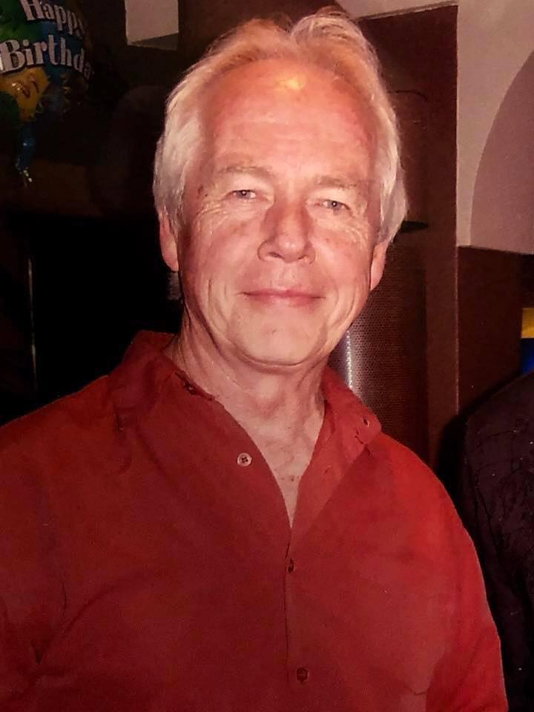
If all had gone according to plan, Victor and I would have presented a joint paper at this conference, resuming a collaboration that goes back many years. Victor had also promised to say a few words about Michael, who had long been a close friend. He was looking forward to coming to Venice, a city he had never previously visited. I got to know Victor after I arrived in Australia in 1986, oddly enough to take up the position he had recently vacated at the University of New South Wales. One day he invited me up to his home (formerly a prison governor’s house and before that one of the first inns built in New South Wales) in East Maitland and suggested we might work on a research project together. I was already aware of Victor’s interest in theatre audiences, a topic to which I felt increasingly drawn, and out of that meeting the project that was to result in our joint monograph, Reflecting the Audience, was born. The collaboration proved very fruitful and Victor and I became good friends. He was a generous host and over the years I spent many happy hours with Victor and his wife, Danusia. I last met up with him in Sydney in August 2017: he was walking with a stick but otherwise was the same old Victor. I still can’t quite believe he is no longer with us.
Jim Davis
After completing his PhD in Classics at Stanford University in California (supported by a Fulbright Scholarship), Victor’s career as a Drama academic commenced in 1965 when he was appointed to Australia’s first-ever Department of Drama at UNSW (1965-1986). He was appointed to the Chair of Drama at the University of Newcastle in 1986. His enjoyment of collaborative work was evident in his academic work on nineteenth-century theatre and in his theatrical practice He established the IFTR working group on popular entertainments, which he convened from 2006-2015, and the e-journal Popular Entertainment Studies. Victor led a very full, rich and busy life, right up to his final years of failing health, when most would be happy to rest on their laurels in quiet retirement. Victor loved his life and work, and all of us who shared some of it are the better for it, and greatly saddened that he has left us.
University of Newcastle, NSW

Friday 8 June

2.00 – 3.00 Registration on arrival at the palazzo

3.00 – 3.30 Introduction by Jim Davis, Tracy C. Davis, and Judy Booth, Main Lecture Hall

3.30 – 4.30 Keynote 1, Main Lecture Hall

Nicholas Daly, University College Dublin
Chair: Sharon Aronofsky Weltman

City on Fire: The Pleasures of Urban Catastrophe on the Nineteenth-Century Stage

4.30 – 5.00 Coffee Break

5.00 – 6.30 Michael Booth Memorial Panel, Main Lecture Hall

The Legacy and Challenges of Victorian Spectacular Theatre 1850-1910
Chair: Tracy C. Davis

Aileen Robinson, Stanford University

The Fairyland of the City: Dion Boucicault's Babil and Bijou and London’s Technological Spectacle

Tracy C. Davis, Northwestern University

George Cruikshank’s Comet of 1853

David Mayer, University of Manchester

The City in Flames

6.30 – 8.00 Reception in the Palazzo Garden

Saturday 9 June

9.00 – 10.30 Panels 1

1.A: Venice in Performance/Venice as Performance Space, Main Lecture Hall
Chair: Mary Isbell

Peter O’Rourke, University of Exeter

The Elephant in the Church: The Carnival of Venice in the Long Nineteenth Century

Mimmi Woisnitza, Leuphana University, Lüneburg

Staging Venice: Max Reinhardt's Merchant of Venice (1905-1934)

Minna Vuohelainen, City, University of London

‘[T]his great open-air ballroom’: Venice as a Stage in Vernon Lee’s ‘A Wicked Voice’

1.B: Crime/the Whitechapel Murders, Seminar Room I
Chair: Oskar Cox-Jensen

Justin A. Blum, University of Lethbridge, Alberta

‘Scene at a Waxworks’: Obscenity and Performance at an East End Penny Gaff, 1889

Sophie Duncan, University of Oxford

‘Cat-worrying and woman-mutilation’: Popular Performance and ‘personating’ the Ripper

Clare Clark, Trinity College, Dublin

‘A Shrine of Pilgrimage’: Dark Tourism in late-Victorian London, Crime Writing, and Israel Zangwill's The Big Bow Mystery (1891)

1.C: City Pageants/National and Civic Identities, Seminar Room II
Chair: Carolyn Williams

Christina Vollmert, University of Cologne

Location & Nation - Theatrical Representations of the Past in Fin-de-Siècle Frankfurt/Main

Tommaso Zerbi, University of Edinburgh

King Charles Albert’s Funeral in Turin and the Spectacle of the Middle Ages

Sara Ayres, National Portrait Gallery, London

The Progress of the Princess Alexandra of Denmark, 7 March 1863

10. 30 – 11.00 Coffee Break

11.00 – 12.30 Panels 2

2.A: Realism, Topicality, Localisation, Main Lecture Hall
Chair: Kate Newey

Louis James, University of Kent

‘Enter Dusty Bob and Black Sal’: Dramatisations of Pierce Egan's Life in London (1821) and their Impact on Social Realism on the Regency Stage

Sarah Meer, University of Cambridge

Translating the Spectacular City: Les Pauvres de Paris, Poverty and Pride, The Poor of New York

Hayley Jayne Bradley, Sheffield Hallam University

Wrought by Nature and Stimuli for Spectacle; ‘Behold the [stage] imitation’ of Real Life Disasters

2.B: Mapping Performance in London, Seminar Room I
Chair: Daniel O’Quinn

David Coates, University of Warwick

Expanding ‘London Theatre’: Dramatic Entertainments in the Suburbs

Moira Goff, Garrick Club, London

Towards a Topography of Stage Dancing in London, 1800-1830

Laura Monrós-Gaspar, Universitat de València, Spain

Mapping Classical London: Victorian Women Playwrights and the Classics

12.30 – 2.30 Lunch at Trattoria Stocia

2.30 – 4.00 Panels 3

3.A: Society, Materiality, and Advertising, Main Lecture Hall
Chair: Tracy C. Davis

Jenny Hughes, University of Manchester

Social Theatre in the Victorian Age

Kate Newey, University of Exeter

Pantomime Materiality and the City

Laurence Senelick, Tufts University

Signs of the Times: Outdoor Theatrical Advertising in the Nineteenth Century

3.B: The City as Theatre, Seminar Room I
Chair: Moira Goff

Tim Butler Garrett, Independent Scholar

Vienna, Synthesising Metropolis

Mikolaj Getka-Kenig, Jagiellonian University, Cracow

City Space, Public Ceremony and Political Legitimacy in Warsaw, 1815-1830

Marina Merkulova, Moscow City Pedagogical University and Inna Merkulova, State Academic University of the Humanities, Moscow

Semiotics of the City Theatre Space of Russia in the Nineteenth Century

3.C: Performers and the City, Seminar Room II
Chair: Katherine Astbury

Daniel O’Quinn, University of Guelph

Kemble's Eternal City

Miranda Welby, Independent Scholar

Towards Modern Spectacle: The Actor as Image in Johnston Forbes-Robertson's Romeo and Juliet of 1895

Victoria Duckett, Deakin University, Melbourne

Multiple Sightings: Sarah Bernhardt in the City

4.00 – 4.30 Coffee Break

4.30 – 5.30 Keynote 2, Main Lecture Hall

Lynda Nead, Birkbeck, University of London
Chair: Patricia Smyth

Dickens Noir: The Shadows of Victorianism in Post-War British Art and Culture
c. 1945-55

5.30 – 5.45 Coffee Break

5.45 – 7.15 Panels 4

4.A: Optical Entertainments: the Eidophusikon, Panoramas, and Peep Shows, Main Lecture Hall
Chair: Jenny Hughes

Shearer West, University of Nottingham

Virtual Reality avant le lettre: De Loutherbourg and the Origins of Urban Spectacle

John Plunkett, University of Exeter

Moving Shows, Touring Pictures: Panoramas and Provincial Cities 1810-1830

Shijia Yu, Birkbeck, University of London

‘[W]hen you get inside [...] you are part of the show’: The Theatre Paper Peepshow and the Self-Regulation of the Urban Spectators

4.B: Shipboard Theatricals/Maritime Performance, Seminar Room I
Chair: Michael Burden

Mary Isbell, University of New Haven

Spectacle at Sea: The Merry Monarch off the Coast of Jeddah

Oskar Cox Jensen, Queen Mary University of London

Messing About with Boats: Ships and Spectacle on the London Stage and Street

Mark Cosdon, Allegheny College, Meadville

The Hanlon Brothers and Chicago's Columbian Exposition

Sunday 10 June

9.00 – 10.30 Panels 5

5.A: The Operatic City, Main Lecture Hall
Chair: Michael Pisani

Alexandra Wilson, Oxford Brookes University

Puccini’s Paris: City of the Imagination?

Barbara Eichner, Oxford Brookes University

‘The clock's struck 10!’ Performing Time in Richard Wagner’s Cityscapes

Tim Lloyd, Oxford Brookes University

‘Spectacle trop beau, peut-être’: Performing the Expositions Universelles at the Palais Garnier

Anna Maria Barry, Royal College of Music Museum

‘... not what is expected, perhaps, in memoirs such as these’: The Operatic City in Michael Kelly's Reminiscences

5.B: Mystery and the Detective, Seminar Room I
Chair: Hayley Jayne Bradley

Sara Hackenberg, San Francisco State University

City Mysteries, Minstrelsy, and Melodrama: Performance Genres as Politics in Mid-Century Transatlantic Urban Fiction

Isabel Stowell-Kaplan, University of Toronto

Stage Detectives of Spectacular Deceit: Policing Urban Crime in The Ticket-of-Leave Man and The Detective

Lee Michael-Berger, Beit Berl College and Sapir College, Israel

Miserable Kate – Urban Space and Tragedy in Representations of a Late Victorian Spitalfields Murder

5.C: Inspiration, Temptation, Consumption, Seminar Room II
Chair: David Coates

Anna Sica, University of Palermo

Eleonora Duse and Alexandr Volkoff-Muromcey in Venice

Vito Adriaensens, Columbia University

Venice Carnival in a Dutch Garden: Prunella’s Sinful Mummers

Tim White, University of Warwick

The Degustation of Paris: Grimod’s Almanach des Gourmands

10.30 – 11.00 Coffee Break

11.00 – 12.30 Panels 6

6.A: Staging Napoleonic Theatre in Paris, London, and the Provinces, Main Lecture Hall
Chair: Sarah Meer

Katherine Astbury, University of Warwick

Melodrama in Paris and the Provinces: La Forteresse du Danube as Case Study

Sarah Burdett, University of Warwick

From Paris to London to Yorkshire: Responding to French Melodramas in Nineteenth-Century London and Twenty-First-Century Yorkshire

Devon Cox, University of Warwick

Bringing Paris to Portchester – Actors and Staging in Roseliska [This paper will be presented by Katherine Astbury]

Diane Tisdall, University of Warwick

Music for the French Prisoners’ Theatre at Portchester Castle: Creating a Pixerécourtian Melodrama Score as Practice-Led Research

6.B: Music and Opera, Seminar Room I
Chair: Caroline Radcliffe

Michael V. Pisani, Vassar College

Drama and Music at ‘The Grecian’, a Nineteenth-Century Northeast London Theatre

Michael Burden, University of Oxford

Operatic Cities under Siege

Effie Papanikolaou, Bowling Green State University, Ohio

Dance and the City: Degas’s Ballerinas at the Opera

6.C: Urban Geographies, Seminar Room II
Chair: Marty Gould

Angelina Del Balzo, University of California, Los Angeles

‘Ultra-orientalists’ and the Arabian Nights on the London Stage

Jim Davis, University of Warwick

The Theatrical Life and Death of Wych Street

Ailsa Brackley du Bois, Deakin University, Melbourne

The Wild West of Victorian Australia: Theatrical Entertainment & Interaction in 1850s Ballarat

12.30 – 1.00 Coffee Break

1.00 – 2.30 Panels 7

7.A: Religion and Morality, Main Lecture Hall
Chair: Jim Davis

Yair Lipshitz, Tel Aviv University

Suspicion and Spectacle: Textual Traditions, National Consciousness, and the Staging of Jerusalem in Avrom Goldfadn’s Shulamis

Leanne Waters, University College Dublin

Divine Presence and the Melodramatic Tableau: Paul M. Berton and Herbert Woodgate’s 1897 Stage Adaptation of The Sorrows of Satan

Andrew Holden, Oxford Brookes University

Opera Avanti a Dio! Rome's Reception of Religion in Opera 1870-1900

7.B: The City on Stage and as Performance Space, Seminar Room I
Chair: Sophie Duncan

Keri Walsh, Fordham University, New York

Hungry in London: Sydney Owenson’s Temper

Jeremy Newton, Birkbeck, University of London

Staging London in Late-Victorian Melodrama

Christina Jen, Rutgers University

Reading from City to City: Charles Dickens and the Public Reading Spectacle

7.C: Dance, Movement, Public Space, Seminar Room II
Chair: Victoria Duckett

Elisa Uffreduzzi, University of Florence

Tarantella Dance in Early Cinema: A Pillar of Neapolitan Urban Architecture

Brian Hurwitz, Kings College London

A Metropolitan Medical Observatory of Human Dysmobility

Craig Melhoff, Concordia University, Montreal

Subterranean Spectacle: The Literature of the London Underground

2.30 – 2.45 Afterword, Main Lecture Hall

Baz Kershaw, University of Warwick
Chair: Janice Norwood

Catastrophic Cities! Previewing the Anthropocene

CLOSE OF CONFERENCE

Palazzo Pesaro-Papafava Information

Location and Travel
The Palazzo Pesaro-Papafava is situated in the heart of historic Venice, a few minute’s walk from two of Venice’s most famous icons: the Rialto Bridge and the Ca’ d’Oro. Lying along the banks of the Canale della Misericordia, opposite the Scuola Grande della Misericordia, its balconies afford views towards the Grand Canal as well as to the Lagoon.
The Palazzo Pesaro-Papafava is easily accessible by land and water:
- 12-minute walk to Venice’s Santa Lucia Railway Station
- 10-minute ride by water taxi from Venice’s Marco Polo Airport
- 3-minute walk to the Ca’ d’Oro vaporetto stop on the Grand Canal, which is serviced by the number 1 water bus
- 4-minute walk to the Santa Sofia traghetto stop, which takes one across the Grand Canal to the Rialto markets

Address and Contact Details
The University of Warwick in Venice
Palazzo Pesaro Papafava (Casanova Museum)
Calle de la Rachetta
Cannaregio 3764
30121 Venezia
Italy / Italia

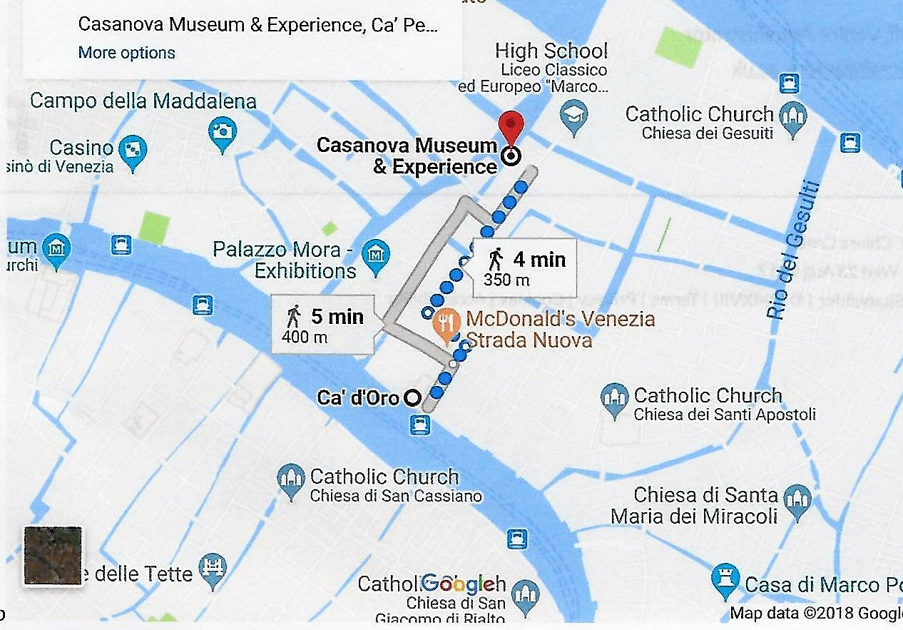

This tribute first appeared on the ASTR website.

